Contents

China Azure CDN 1

Create CDN Endpoint 2

View CDN endpoint details 4

Endpoint General detail 4

Monitor 5

Disable or Delete CDN endpoint 7

Advanced management 8

Overview 9

Domain Management 11

Usage Chart 18

Bandwidth Usage 18

Cache Refresh 19

Content Prefetch 24

## China Azure CDN

The Windows Azure Content Delivery Network (CDN) caches Windows Azure blobs and static content used by cloud services at strategically placed locations across China to provide maximum bandwidth for delivering content to users. China Azure CDN also support origin domains that are not deployed on Azure platform.

You can create a CDN endpoint for a storage account, in order to cache blob data, or for a cloud service, in order to cache static content used by the service. When you create the endpoint, you must provide your custom domain and related ICP number. The Windows Azure Management Portal provides you with a unique URL for accessing your cached content, but you need to create a CNAME resource record with your DNS provider that points from your custom domain to this URL. This URL maps to the origin domain, which is the storage account or cloud service on which you created the endpoint.

## Create CDN Endpoint

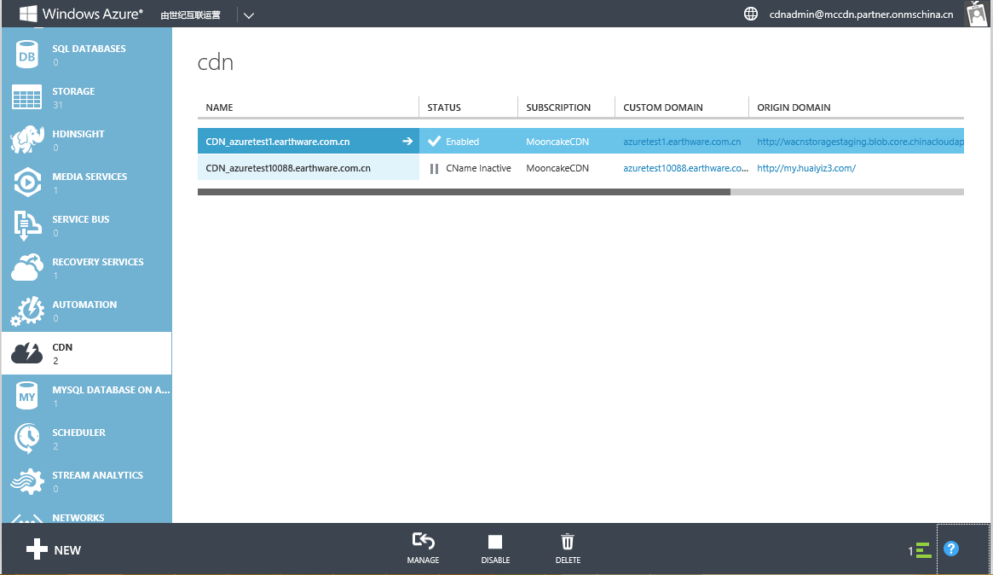

1. Go to Windows Azure CDN, choose CDN and click ‘NEW’’, Click QUICK CREATE.
2. Choose ‘Acceleration Type’, currently China Azure CDN support Web Acceleration, Download Acceleration and VOD Acceleration.

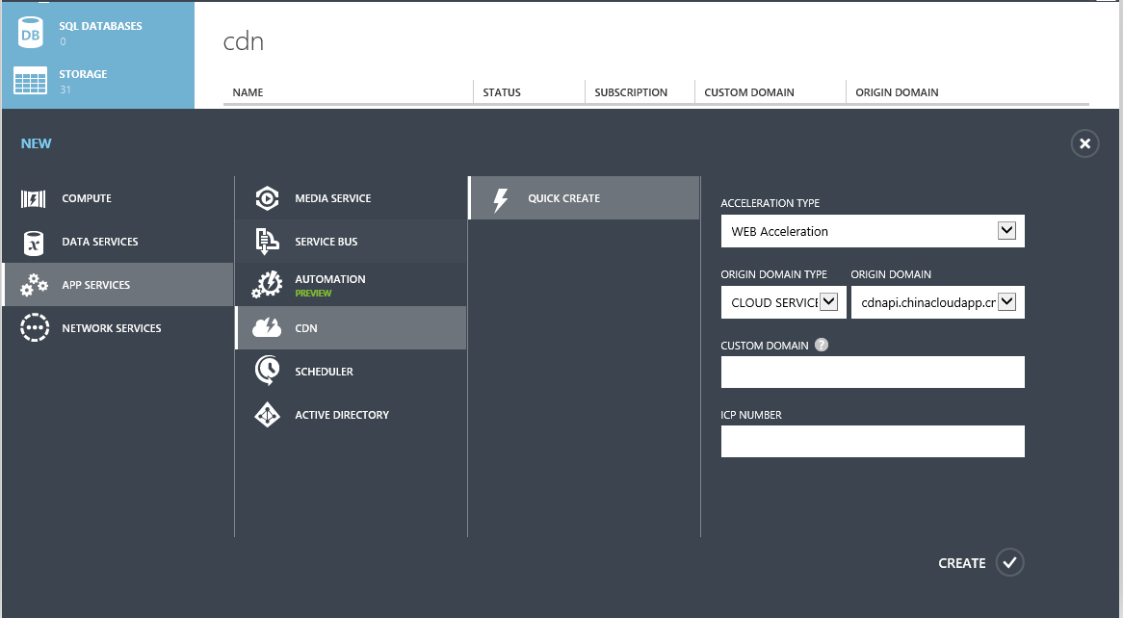

1. Choose ‘Origin Domain Type’, currently we have support 4 options, Cloud Service, Storage Account, Web App and Custom Origin Domain
2. Type in or choose Origin Domain, select an origin domain under selected Origin Domain Type in last step.
3. In ‘Custom Domain’, type the custom domain you are about to use.
4. For ‘ICP Number’, type in the mapping ICP number with above custom domain.

It may take 1 business day to verify if ICP number and custom domain match.

## View CDN endpoint details

### Endpoint General detail

Once you created one endpoint, you can click the CDN endpoint and view general info, see details in screenshot.

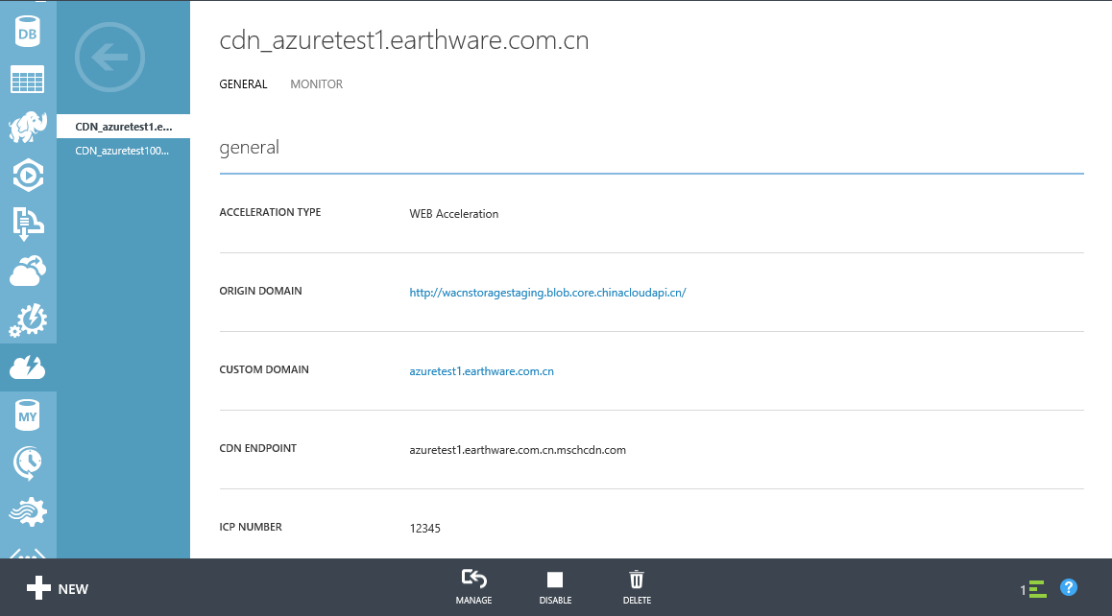

### Monitor

Use the CDN Endpoint monitoring work space to view the bandwidth history for your CDN Endpoint.   The CDN Endpoint monitoring work space displays the following parameters:   Bandwidth – The bandwidth of data received from CDN Endpoint   Use the controls at top right to select Relative or Absolute display, and to specify a 1-hour, 24-hour, or 7-day time scale. Note that you must click the refresh button to change the display.

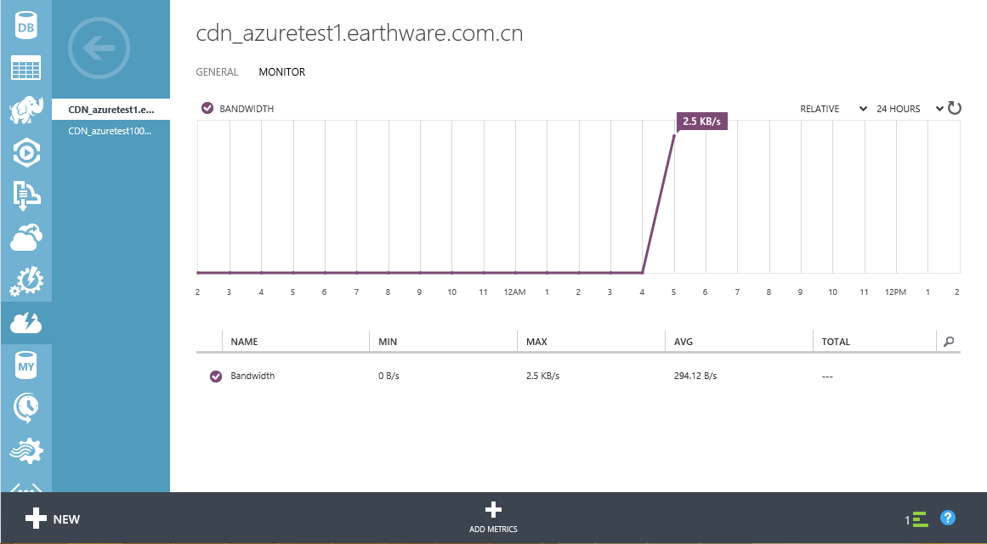

## Disable or Delete CDN endpoint

To stop caching content on a CDN endpoint, you can disable the endpoint. When the endpoint is disabled, content cached by the CDN on that endpoint is not available to users, and the application will need to provide that content from the origin domain, until the endpoint is enabled again.

If you wish to stop caching content on the endpoint altogether, you can delete the endpoint.

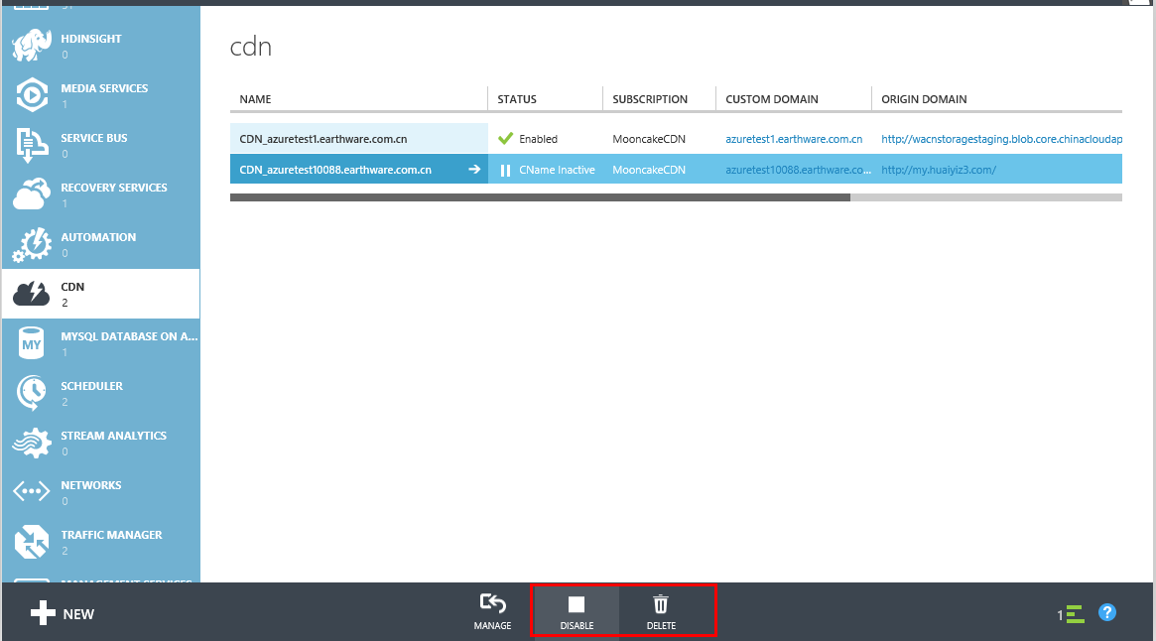

## Advanced management

If you wish to do advanced CDN configurations and/or view reporting, you can click the “manage” button and will be redirected to another website to manage those activities.

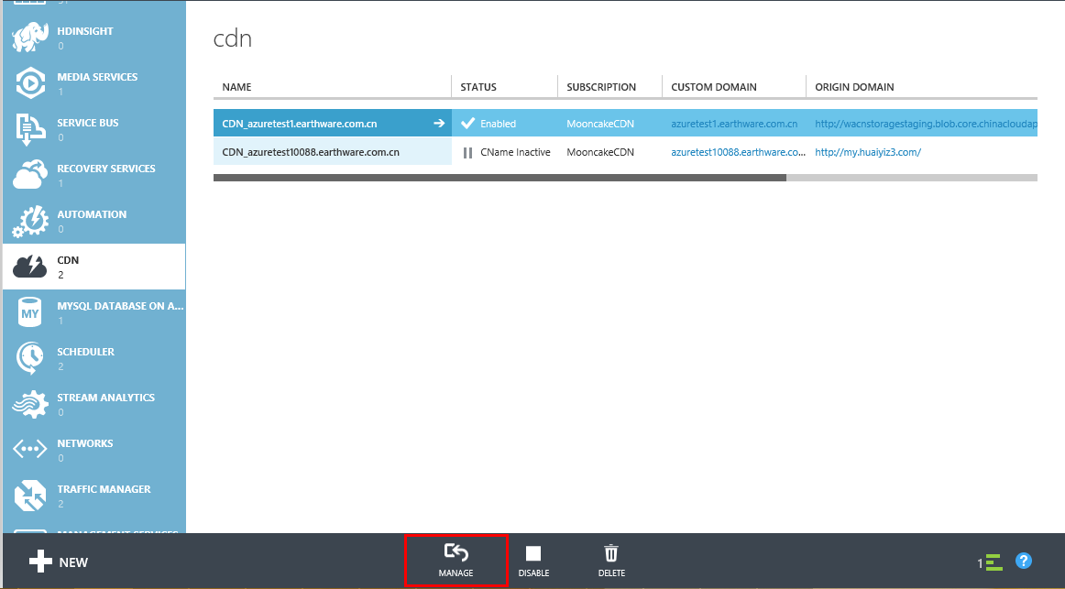

### Overview

In Advance management page, you will see overview of then endpoints you created under selected subscription ID. Total Domain, Total Enabled Domain, Total Usage in Current Month and Bandwidths in Current Months

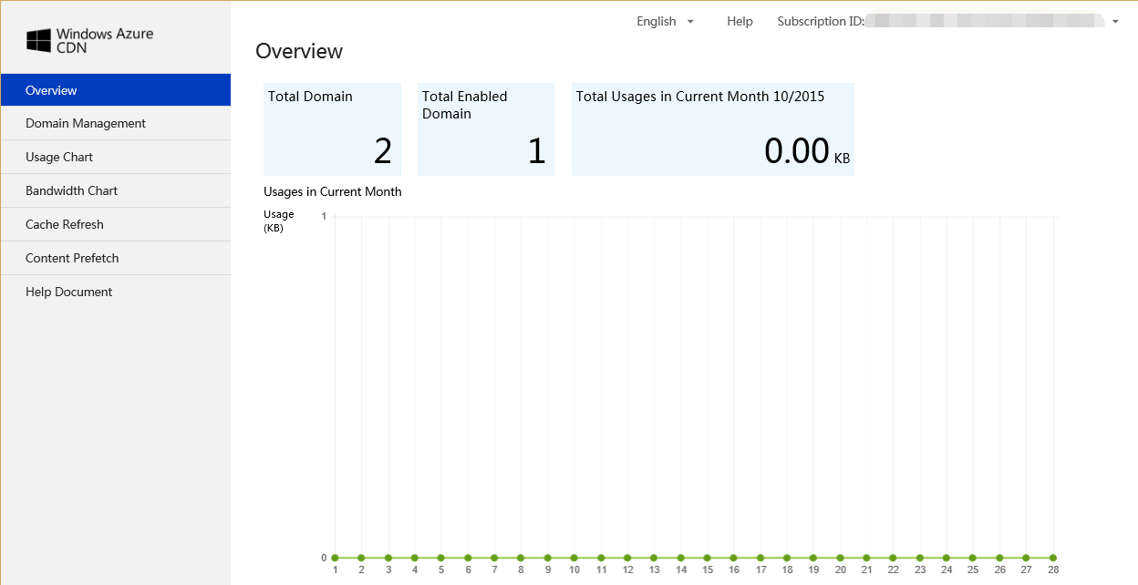

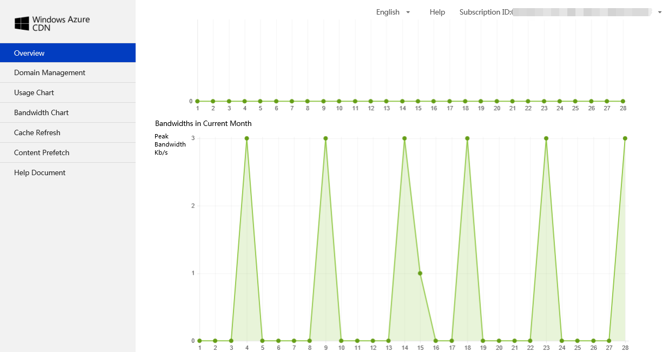

### Domain Management

You can see all the domains list created under selected subscription ID.

You can Modify Configurations, Configure Caching Rules and Access Control Management.

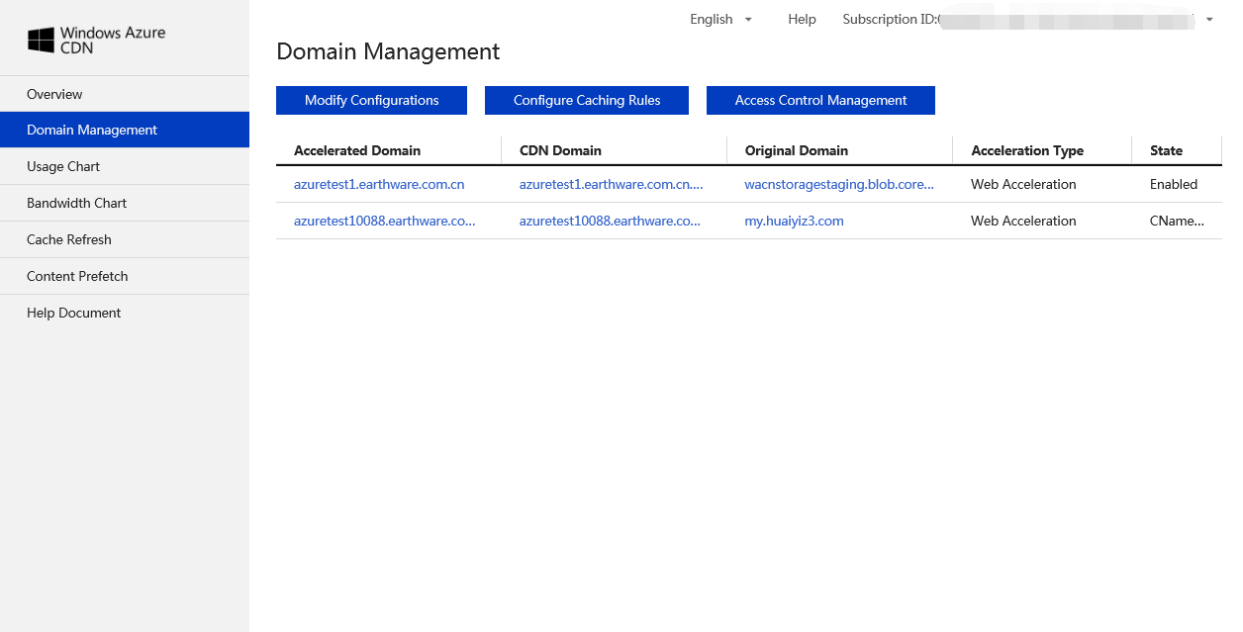

#### Modify origin domain

Windows Azure CDN has default caching rules. You can also customize caching rules and system will apply customized rules. If doesn’t hit customized rules, it will apply default caching rules.

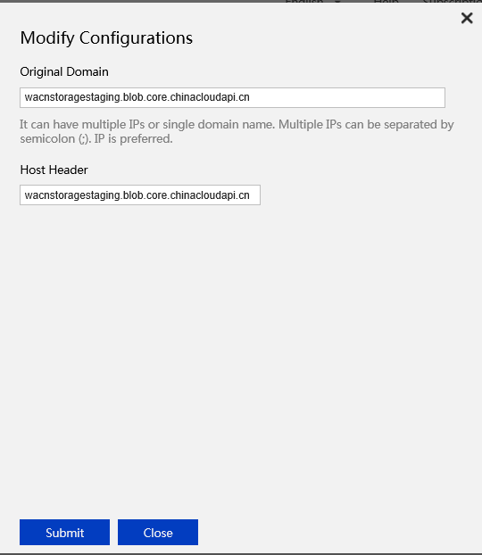

#### Modify caching rules

#### Folder caching rules:

Folder must begin with ‘/’, e.g. "/pic", "/doc", "/htdoc/data", caching rules will apply to all sub folders.

#### File caching rules:

Use common suffix, e.g. "jpg", "png", "gif", "txt", "m4v", "mp3", caching rules will apply to all files with set suffix under specified folder.

#### Caching order

Caching rules follow first-set, first apply.

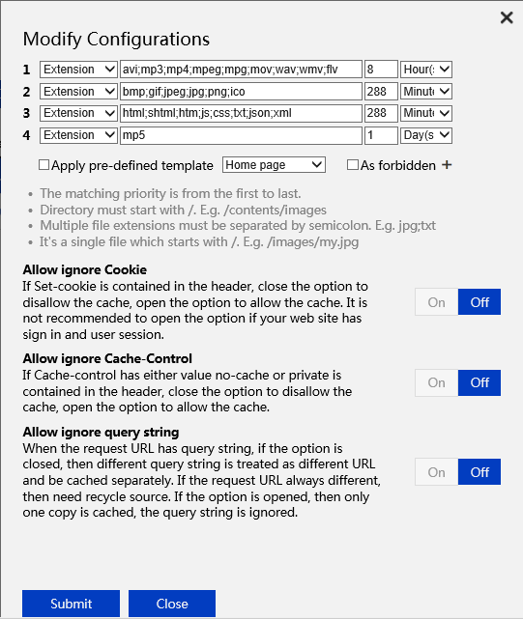

#### Access Control Management

#### Can configure Referer Block list and allowed list to achieve anti-stealing link.

Each rule applies to both folder and files. E.g. all png files under /*.png.

Block list: when Referer is in block list, access is denied. Otherwise can do.

Allow list: only when Referer is in allow list, access is allowed. Otherwise, access denied.

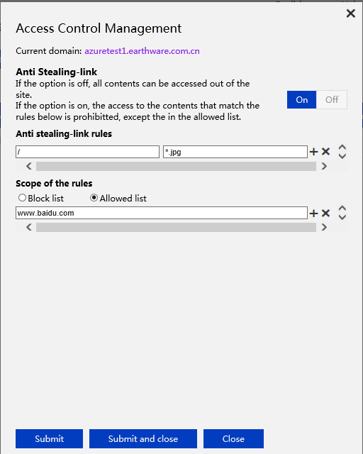

### Usage Chart

Select Subscription ID, acceleration domains and date to view chargable usage.

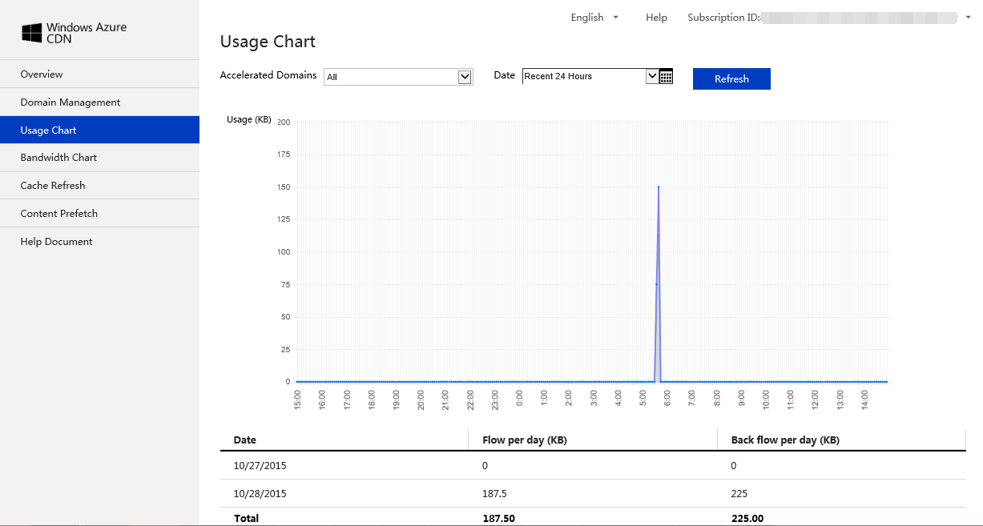

### Bandwidth Usage

Select Subscription ID, acceleration domains and date to view bandwidth usage.

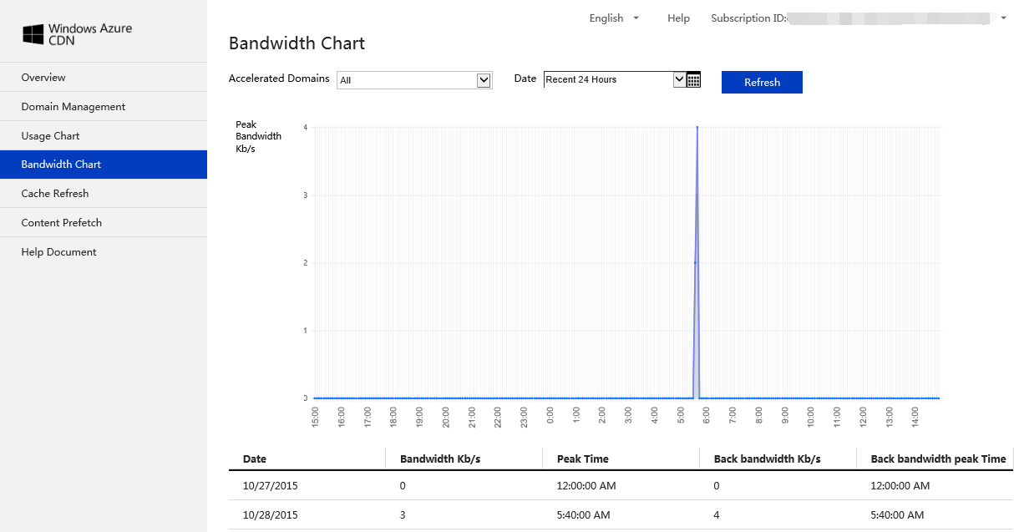

### Cache Refresh

Select Subscription ID, acceleration domains and date to view Cache states. The states has 3 values, Success, Fail and Running. You can also configure cache refresh rules, File Refresh and Folder Refresh.

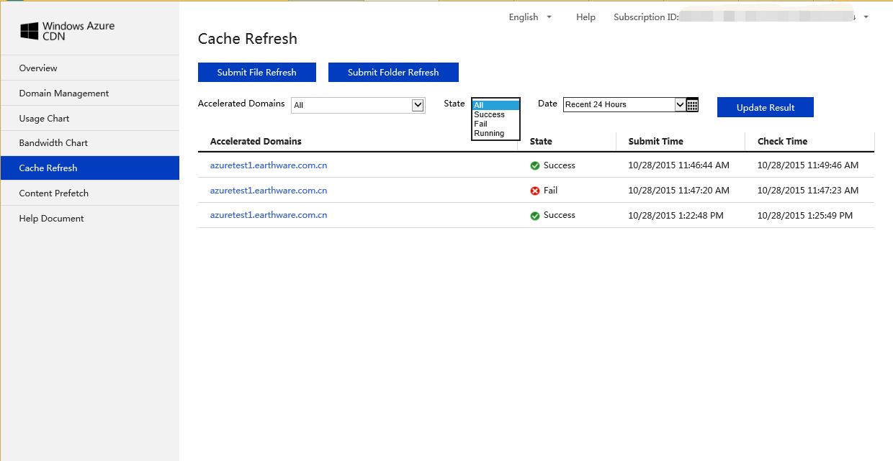

#### File refresh

You can click Submit File Refresh to set File Refreshing rule. Can click ‘+’ to add rules and ‘X’ to delete rules.

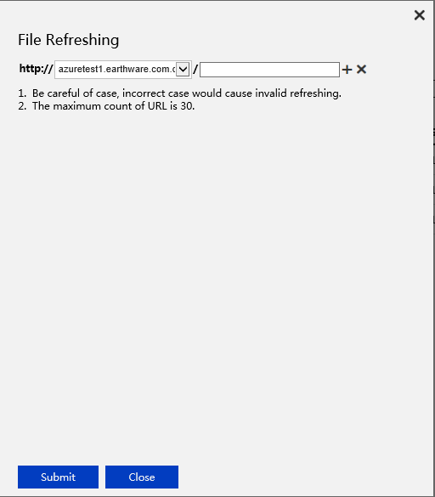

#### Folder Refresh

Submit Folder Refresh to set folder refresh rules. Can click ‘+’ to add rules and ‘X’ to delete rules.

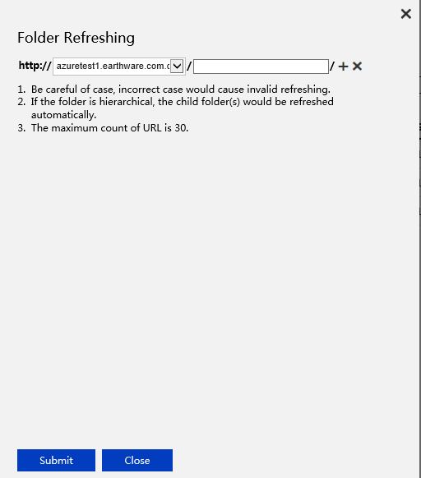

### Content Prefetch

You can select Subscription ID, Acceleration Domains and Date to view content perfetch per your request. It has 3 states: Success, Fail and Running.

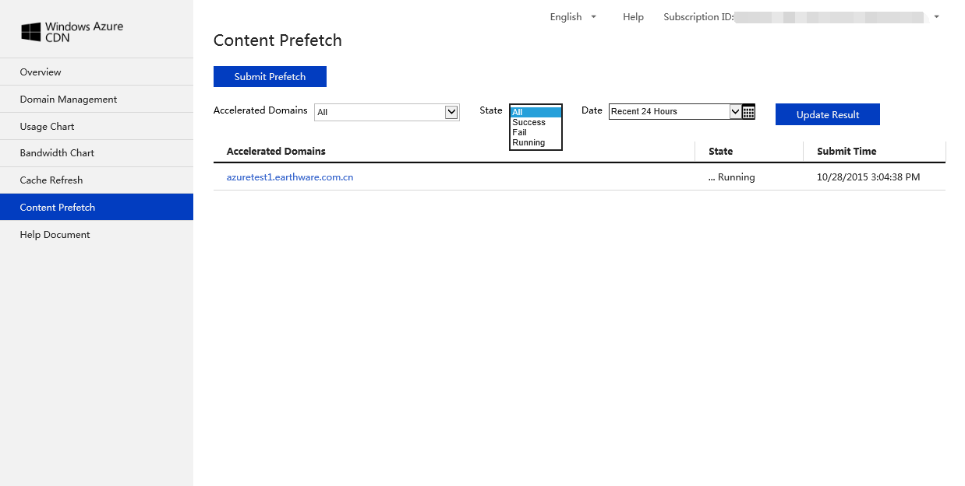

Can submit Prefetch to set rules to prefetch contents, this applies to large file distribution and reduces response time when user access contents the first time.

